WALK-A-THON 2012

ADULT T-SHIRT ORDER FORM

DUE 9-24-12

Event shirts are available to staff and parents for $20.
For parents, your child must have already met the
minimum $50 pledge for their t-shirt.
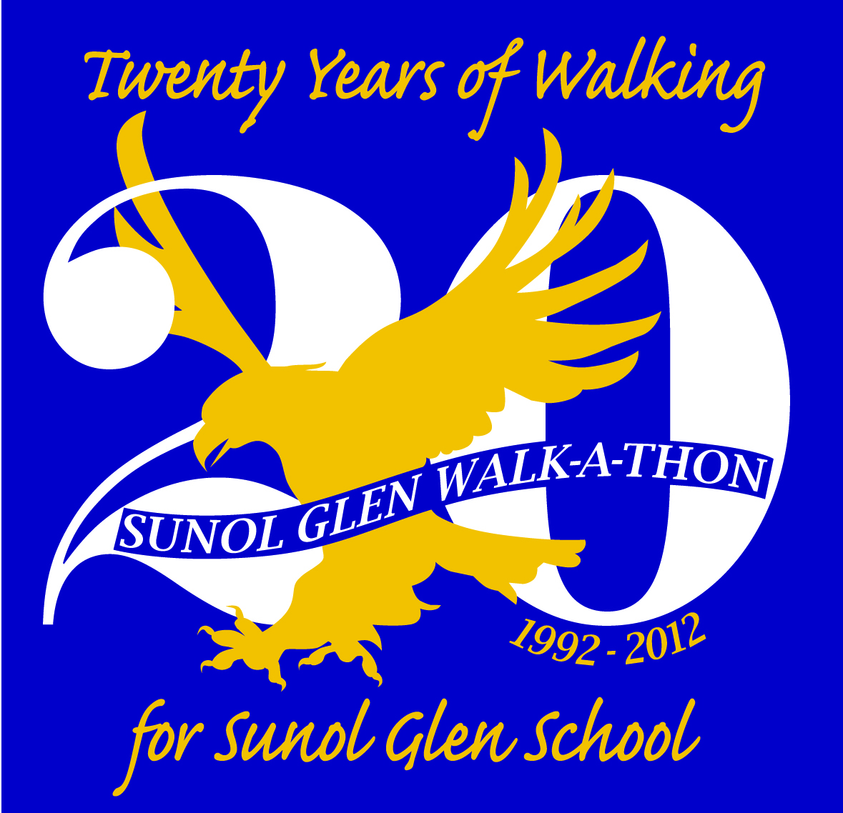
NAME_______________________________ CHILD'S TEACHER _____________________

Shirts will be navy blue. Shirts are the same style as last year.

 | Ladies' Shirts (V-neck, sizes run small) |  |  |  |  | Men's Shirts (Crew Neck)
 | Adult  Small | Adult Medium | Adult  Large | Adult  XL | Adult  2XL | Adult Small | Adult Medium | Adult Large | Adult XL | Adult 2XL
Length: | 25.5" | 26" | 26.5" | 27.5" | 28" | 28" | 29" | 30" | 31" | 33"
Width: | 16.5" | 17.5" | 18.5" | 19.5" | 20.5" | 18" | 20" | 22" | 24" | 26"
My Choice:

Please attach cash or check for $20 payable to the Sunol Glen Community Club. Please turn form into the office.

