 | Sponsor | Flat Donation/Per Lap | Total Donation
1
2
3
4
5
6
Total Pledges Collected

Twenty Years of Walking for Sunol Glen

PLEDGE/DONATION FORM

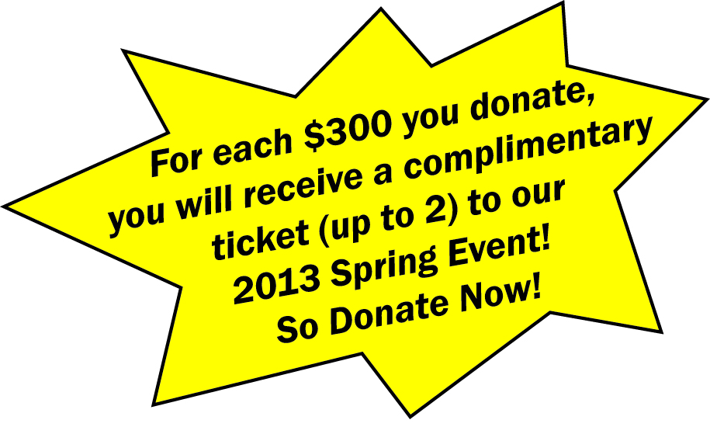
Enclosed is my donation of:

____ $50 I would like a T-Shirt and have filled out the T-shirt form on back
____ $300 (1) complete the yearly per-student goal,
(2) receive my free T-Shirt (fill out form on back),
(3) receive one entry into the Pledge Raffle for a prize to be determined, and
(4) receive 1 complimentary ticket to the SGCC 2013 Spring Event.

____ I would like to spread my pledge out over several months as noted below:
$______ per month for ______ months = $______ Total Pledge
You will receive incentive awards once the total pledge has been received. Please include at least a $50 payment with this form to receive a free t-shirt.

____ $______ Other Amount (We are grateful for anything!)

PARENT NAME__________________________________ PHONE ______________________
EMAIL ADDRESS________________________________ I will be paying by credit card**____
**Checks are preferred as Community Club is charged a 3% transaction fee for credit cards, but we are happy to accept credit cards if that works best for you. Our Treasurer will be contacting you to arrange credit card payment(s)

Incentive Note: All pledges must be received before incentives will be awarded. You will earn an entry into the Pledge Raffle with a pledge of $300/student or more but if you win the raffle, you will not receive your tickets until your completed pledge has been received. Raffle drawing will be held October 15th.
GENERAL INFORMATION
- The per-student SGCC goal is $300
- Please submit one form per student
- To write one check for multiple students, just staple the forms together
- Make checks payable to "Sunol Glen Community Club" or "SGCC"

PLEDGE INFORMATION
“On Friday, October 5th, I am participating in the Sunol Glen 20th Annual Walk-A-Thon to raise funds for my school. I will walk as many laps as I can in one hour, a minimum of 8 laps.”

STUDENT NAME__________________________________ TEACHER _____________________

Girls Sizes (run small)
 | S | M | L | XL
Length  (Collar to Bottom) | 23 | 24 | 25 | 27
Width  (side to side ) | 14.75 | 15.75 | 16.75 | 18.75

Boys
 | S | M | L | XL
Length  (Collar to Bottom) | 20.5 | 23 | 25 | 27
Width  (side to side ) | 15.5 | 17 | 18 | 20

