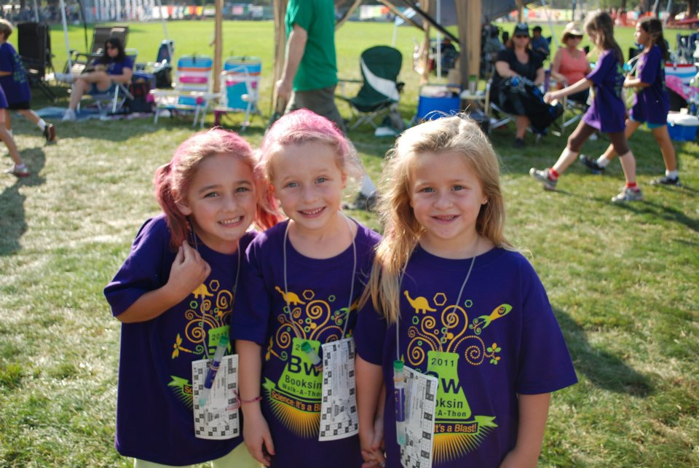

20th Annual Sunol Glen

Walk-A-Thon 2012



Sunol Glen is Groovy!

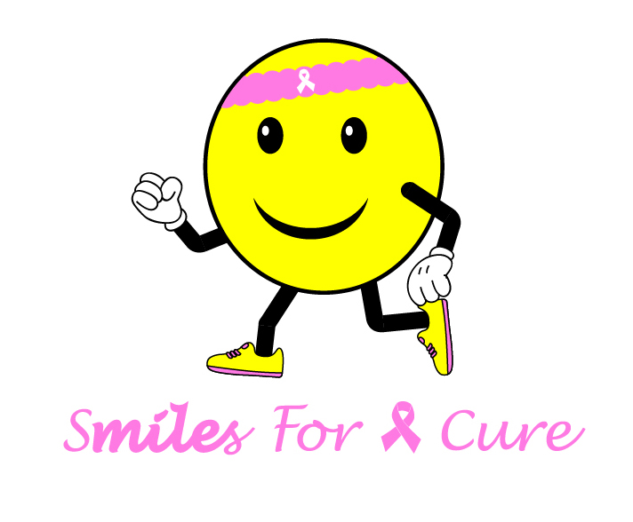**Smiles for Miles**

**20th Annual Sunol Glen**

**Walk-A-Thon 2012**

**Thumbs up for Sunol Glen !**

**20th Annual Sunol Glen**

**Walk-A-Thon 2012**

**C:\Users\Kindra\AppData\Local\Microsoft\Windows\Temporary Internet Files\Content.IE5\E0R8K5Y1\MC900000950[1].wmfStride with Pride**

**20th Anual**

**Sunol Glen Walk-A-Thon**

**Would probably need to be in school colors since it's talking about "pride"**

**C:\Users\Kindra\AppData\Local\Microsoft\Windows\Temporary Internet Files\Content.IE5\N0H02J26\MC900031024[1].wmfWalk on the Wildside**

**Walk-A-Thon 2012**

**Suggest just doing this on a solid color shirt like last year. But maybe not navy, maybe more royal blue to be different? On the back we could put a boarder of wild animal prints and say "20th Annual Sunol Glen Walk-A-Thon"**

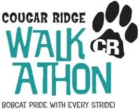

**A version of this might be good too. "Eagle Pride with Every Stride!"**



**Not my personal favorite art, but I like the slogan. Probably not best for a WALK a thon**

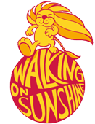

**with a little artistry it could be an eagle on top?!**



**Wish we had this as a year-long theme otherwise I'm not sure it makes sense. But still, a cool logo.**

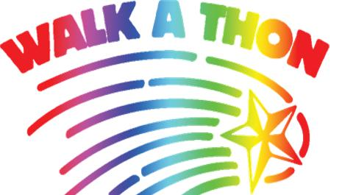

**Would be pretty on a solid color t-shirt and simple. Or could use the tag line "Eagles reach for the Stars" or "Sunol Glen reaches for the Stars" , or simply "Reach for the Stars". We could even be really cheesy and put on the back one of my favorite quotes "Shoot for the Moon, even if you miss you'll land among the Stars". Ok, on that note, I should go ; )**

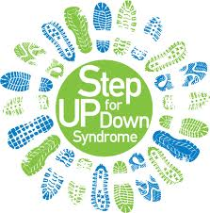

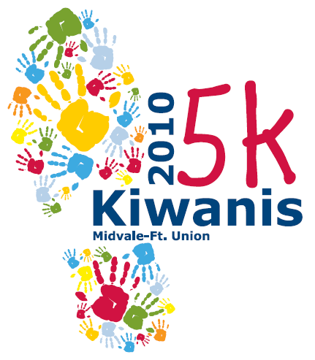

**for another potential event**