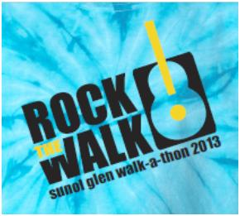
21st Annual Sunol Glen Walk-A-Thon
Rock the Walk
Duncan Hicks-Frazer
Top Lap Runner

21st Annual Sunol Glen Walk-A-Thon
Rock the Walk
Spencer Capuzelo
Kindergarten Top Lap Runner

21st Annual Sunol Glen Walk-A-Thon
Rock the Walk
Chloe Gronley
Kindergarten Top Lap Runner

21st Annual Sunol Glen Walk-A-Thon
Rock the Walk
Karlo Rosales
First Grade Top Lap Runner

21st Annual Sunol Glen Walk-A-Thon
Rock the Walk
Dallas Gonci
2nd Grade Top Lap Runner

21st Annual Sunol Glen Walk-A-Thon
Rock the Walk
Abigail Huang
3rd Grade Top Lap Runner

21st Annual Sunol Glen Walk-A-Thon
Rock the Walk
Seir Ahmadi
4th Grade Top Lap Runner

21st Annual Sunol Glen Walk-A-Thon
Rock the Walk
Sebastian Palomino
5th Grade Top Lap Runner

21st Annual Sunol Glen Walk-A-Thon
Rock the Walk
Angus Hicks-Frazer
6th Grade Top Lap Runner

21st Annual Sunol Glen Walk-A-Thon
Rock the Walk
Joseph Chang
7th Grade Top Lap Runner

21st Annual Sunol Glen Walk-A-Thon
Rock the Walk
Justin Yeung
7th Grade Top Lap Runner

21st Annual Sunol Glen Walk-A-Thon
Rock the Walk
Garrett Takei
7th Grade Top Lap Runner

21st Annual Sunol Glen Walk-A-Thon
Rock the Walk
Mrs. Dorighi
Top Staff Lap Runner

21st Annual Sunol Glen Walk-A-Thon
Rock the Walk
Thank You
For Your Help & Support!

21st Annual Sunol Glen Walk-A-Thon
Rock the Walk
Thank You
For Your Help & Support!

21st Annual Sunol Glen Walk-A-Thon
Rock the Walk
Thank You
For Your Help & Support!

21st Annual Sunol Glen Walk-A-Thon
Rock the Walk
Thank You
For Your Help & Support!

21st Annual Sunol Glen Walk-A-Thon
Rock the Walk
Thank You
For Your Help & Support!

